Search Services

1. **ServicesRepository.java: lấy hết**
2. **ServiceServices thêm**

public List<Services> listByName(String keyword, String type){  
 List<Services> servicesList = (List<Services>) servicesRepository.findAll();  
 if (keyword!= null && type != null){  
 servicesList.stream().filter(se->se.getName().toLowerCase().contains(keyword.toLowerCase())).collect(Collectors.*toList*());  
 servicesList.stream().filter(se->se.getType().toLowerCase().contains(type)).collect(Collectors.*toList*());  
 return servicesRepository.search(keyword, type);  
 }else {  
 return (List<Services>) servicesRepository.findAll();  
 }  
}

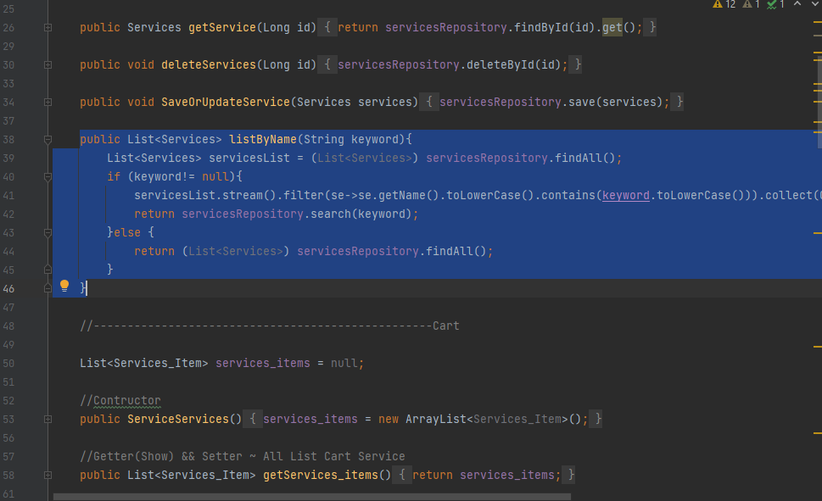

1. **ClientController**
2. List<Services> servicesList = serviceServices.listByName(key, type);  
   model.addAttribute("services_list",serviceServices.listByName(key, type).stream().filter(s -> s.getType().contains("Kg")||s.getType().contains("Item")).collect(Collectors.*toList*()));

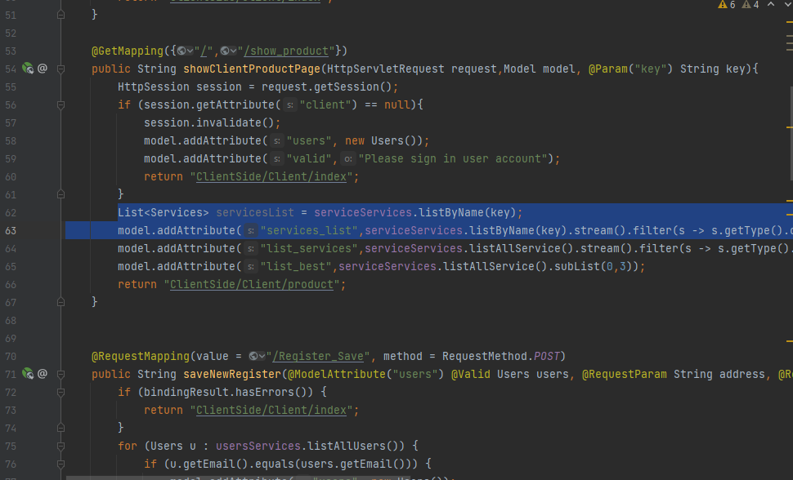

1. **fragmentsClient.html**

<div class="main-search">  
 <form class="example" th:action="@{/show_product#search}">  
 <select name="type" id="type">  
 <option value="#" disabled>--Select--</option>  
 <option value="Kg">Kg</option>  
 <option value="Item">Item</option>  
 </select>  
 <input type="text" placeholder="Search.." name="key">  
 <button type="submit"><i class="fa fa-search"></i></button>  
 </form>  
</div>

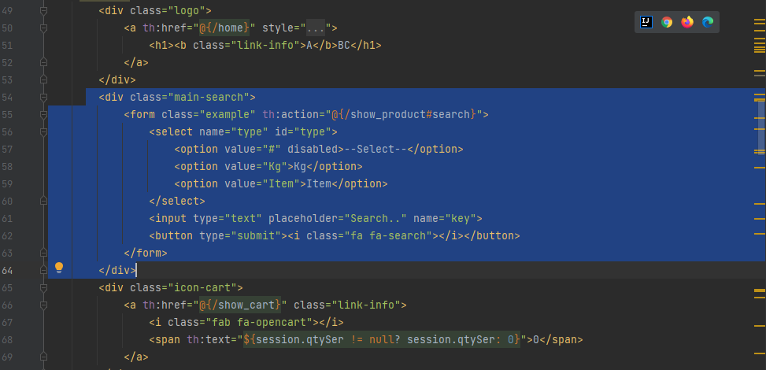

1. **product.html**

**Thay danh sách**

th:each="se : ${services_list}"

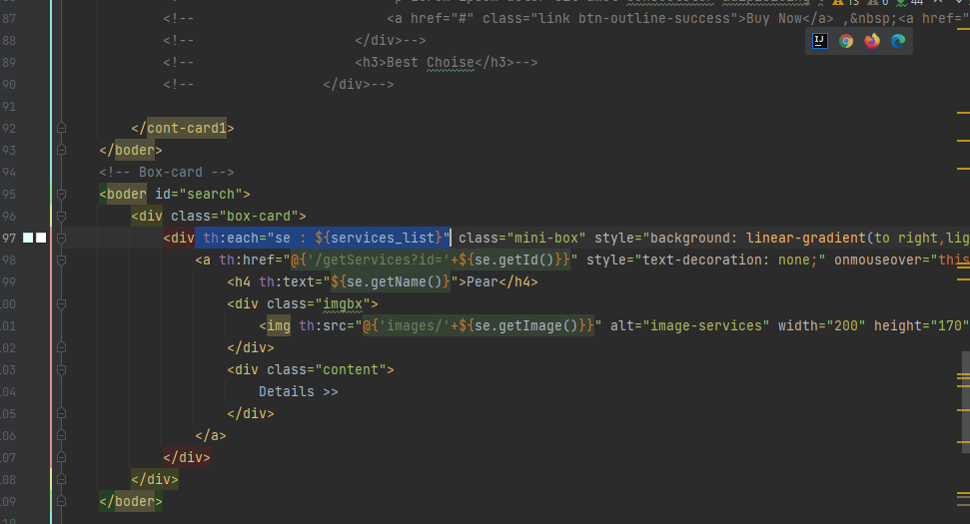

Highcharts

1. **OrdersController.java**

List<Date> dates = ordersServices.listAllOrders().stream().map(x->x.getCreated_at()).collect(Collectors.*toList*());  
List<Float> priceList = ordersServices.listAllOrders().stream().map(x->x.getPayment()).collect(Collectors.*toList*());  
model.addAttribute("dates", dates);  
model.addAttribute("price", priceList);

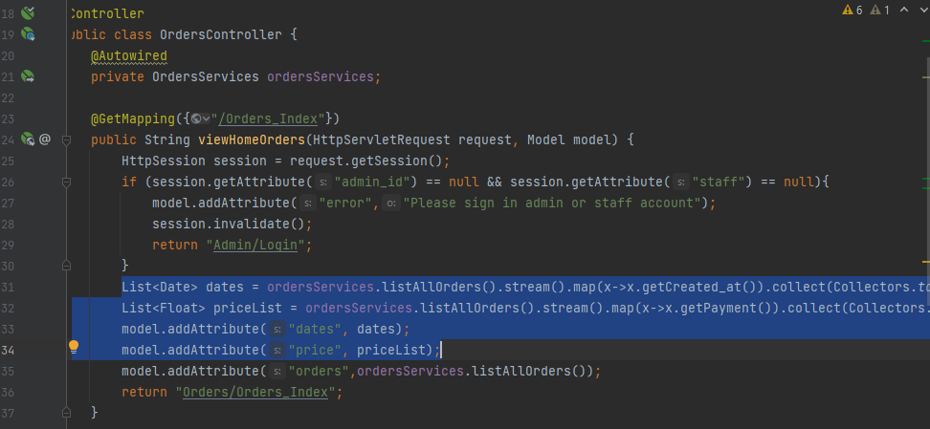

**2.Orders_Index.java**

--Highcharts-->  
<!-- Optional theme -->  
<link rel="stylesheet"  
 href="https://maxcdn.bootstrapcdn.com/bootstrap/3.3.7/css/bootstrap-theme.min.css" />  
<script  
 src="https://maxcdn.bootstrapcdn.com/bootstrap/3.3.7/js/bootstrap.min.js"></script>  
<script src="https://code.highcharts.com/highcharts.js"></script>  
<script src="https://code.highcharts.com/modules/exporting.js"></script>  
  
<div class="container">  
 <h2 align="center">Data Order Payment</h2>  
  
 <div id="container"  
 style="width: 550px; height: 400px; margin: 0 auto"></div>  
</div>  
<script th:inline="javascript">  
 $(function(){  
 Highcharts.chart('container', {  
 chart: {  
 type: 'column'  
 },  
 title: {  
 text: 'Organization'  
 },  
 subtitle: {  
 text: 'Details'  
 },  
 xAxis: {  
 categories: [[${dates}]],  
 crosshair: true  
 },  
 yAxis: {  
 min: 0,  
 max:100,  
 title: {  
 text: 'Payment'  
 }  
 },  
 tooltip: {  
 headerFormat: '<span style="font-size:10px">{point.key}</span><table>',  
 pointFormat: '<tr><td style="color:{series.color};padding:0">{series.name}: </td>' +  
 '<td style="padding:0"><b>{point.y:.1f} K</b></td></tr>',  
 footerFormat: '</table>',  
 shared: true,  
 useHTML: true  
 },  
 plotOptions: {  
 column: {  
 pointPadding: 0.2,  
 borderWidth: 0  
 }  
 },  
 series: [{  
 name: 'Date',  
 data: [[${price}]]  
 }]  
 });  
 });  
</script>